Санкт-Петербургский национально исследовательский университет

информационных технологий, механики и оптики

Факультет программной инженерии и компьютерной техники



**Курсовая работа №1**

Вариант №75

Часть 2

Выполнил: Балтабаев Дамир Темиржанович

Группа: P3112

Преподаватель: Поляков Владимир Иванович

г. Санкт-Петербург

2020

|  |  |  |  |
| --- | --- | --- | --- |
| Операция | Число входных переменных | Число выходных переменных | Разрядность А |
| C = (A + 1) mod 25 | 5 | 5 | 5 |

|  |  |  |  |  |
| --- | --- | --- | --- | --- |
| N | A1A2A3A4A5 | C0C1C2C3C4 | C | V |
| 0 | 00000 | 00001 | 1 | 0 |
| 1 | 00001 | 00010 | 2 | 0 |
| 2 | 00010 | 00011 | 3 | 0 |
| 3 | 00011 | 00100 | 4 | 0 |
| 4 | 00100 | 00101 | 5 | 0 |
| 5 | 00101 | 00110 | 6 | 0 |
| 6 | 00110 | 00111 | 7 | 0 |
| 7 | 00111 | 01000 | 8 | 0 |
| 8 | 01000 | 01001 | 9 | 0 |
| 9 | 01001 | 01010 | 10 | 0 |
| 10 | 01010 | 01011 | 11 | 0 |
| 11 | 01011 | 01100 | 12 | 0 |
| 12 | 01100 | 01101 | 13 | 0 |
| 13 | 01101 | 01110 | 14 | 0 |
| 14 | 01110 | 01111 | 15 | 0 |
| 15 | 01111 | 10000 | 16 | 0 |
| 16 | 10000 | 10001 | 17 | 0 |
| 17 | 10001 | 10010 | 18 | 0 |
| 18 | 10010 | 10011 | 19 | 0 |
| 19 | 10011 | 10100 | 20 | 0 |
| 20 | 10100 | 10101 | 21 | 0 |
| 21 | 10101 | 10110 | 22 | 0 |
| 22 | 10110 | 10111 | 23 | 0 |
| 23 | 10111 | 11000 | 24 | 0 |
| 24 | 11000 | 00000 | 0 | 1 |
| 25 | 11001 | ddddd | d | d |
| 26 | 11010 | ddddd | d | d |
| 27 | 11011 | ddddd | d | d |
| 28 | 11100 | ddddd | d | d |
| 29 | 11101 | ddddd | d | d |
| 30 | 11110 | ddddd | d | d |
| 31 | 11111 | ddddd | d | d |

|  |  |  |  |  |  |  |  |  |  |  |  |
| --- | --- | --- | --- | --- | --- | --- | --- | --- | --- | --- | --- |
|  | a4a5 | | | | |  | a4a5 | | | | |
| a2a3 |  | 00 | 01 | 11 | 10 | a2a3 |  | 00 | 01 | 11 | 10 |
| 00 |  |  |  |  | 00 | 1 | 1 | 1 | 1 |
| 01 |  |  |  |  | 01 | 1 | 1 | 1 | 1 |
| 11 |  |  | 1 |  | 11 | d | d | d | d |
| 10 |  |  |  |  | 10 |  | d |  | d |
|  | a1=0 | | | | |  | a1=1 | | | | |

Карты Карно:

C1

Сmin(C1) = {X1111, 10XXX} Sa = 6 Sb = 8

C2

|  |  |  |  |  |  |  |  |  |  |  |  |
| --- | --- | --- | --- | --- | --- | --- | --- | --- | --- | --- | --- |
|  | a4a5 | | | | |  | a4a5 | | | | |
| a2a3 |  | 00 | 01 | 11 | 10 | a2a3 |  | 00 | 01 | 11 | 10 |
| 00 |  |  |  |  | 00 |  |  |  |  |
| 01 |  |  | 1 |  | 01 |  |  | 1 |  |
| 11 | 1 | 1 |  | 1 | 11 | d | d | d | d |
| 10 | 1 | 1 | 1 | 1 | 10 |  | d | d | d |
|  | a1=0 | | | | |  | a1=1 | | | | |

Сmin(C2) = {010XX, 01X0X, X1X10, X0111} Sa = 13 Sb = 17

C3

|  |  |  |  |  |  |  |  |  |  |  |  |
| --- | --- | --- | --- | --- | --- | --- | --- | --- | --- | --- | --- |
|  | a4a5 | | | | |  | a4a5 | | | | |
| a2a3 |  | 00 | 01 | 11 | 10 | a2a3 |  | 00 | 01 | 11 | 10 |
| 00 |  |  | 1 |  | 00 |  |  | 1 |  |
| 01 | 1 | 1 |  | 1 | 01 | 1 | 1 |  | 1 |
| 11 | 1 | 1 |  | 1 | 11 | d | d | d | d |
| 10 |  |  | 1 |  | 10 |  | d | d | d |
|  | a1=0 | | | | |  | a1=1 | | | | |

Сmin(C3) = {XX10X, XX011, XX1X0} Sa = 7 Sb = 10

C4

|  |  |  |  |  |  |  |  |  |  |  |  |
| --- | --- | --- | --- | --- | --- | --- | --- | --- | --- | --- | --- |
|  | a4a5 | | | | |  | a4a5 | | | | |
| a2a3 |  | 00 | 01 | 11 | 10 | a2a3 |  | 00 | 01 | 11 | 10 |
| 00 |  | 1 |  | 1 | 00 |  | 1 |  | 1 |
| 01 |  | 1 |  | 1 | 01 |  | 1 |  | 1 |
| 11 |  | 1 |  | 1 | 11 | d | d | d | d |
| 10 |  | 1 |  | 1 | 10 |  | d | d | d |
|  | a1=0 | | | | |  | a1=1 | | | | |

Сmin(C4) = {XXX01, XXX10} Sa = 4 Sb = 6

C5

|  |  |  |  |  |  |  |  |  |  |  |  |
| --- | --- | --- | --- | --- | --- | --- | --- | --- | --- | --- | --- |
|  | a4a5 | | | | |  | a4a5 | | | | |
| a2a3 |  | 00 | 01 | 11 | 10 | a2a3 |  | 00 | 01 | 11 | 10 |
| 00 | 1 |  |  | 1 | 00 | 1 |  |  | 1 |
| 01 | 1 |  |  | 1 | 01 | 1 |  |  | 1 |
| 11 | 1 |  |  | 1 | 11 | d | d | d | d |
| 10 | 1 |  |  | 1 | 10 |  | d | d | d |
|  | a1=0 | | | | |  | a1=1 | | | | |

Сmin(C5) = {0XXX0, X0XX0} Sa = 4 Sb = 6

Sq = 47

Факторизация и декомпозиция:

Sq = 44

­­

Y =

Синтез схемы в булевом базисе:

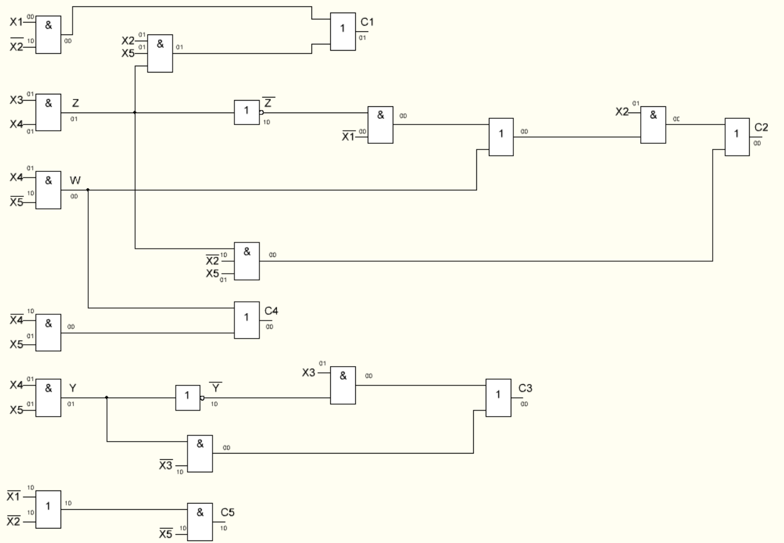

TC1 = 3τ; TC2 = 6τ; TC3 = 4τ; TC4 = 2τ; TC5 = 2τ

T = max(TC1, TC2, TC3, TC4, TC5) = 6τ

Sq = 38